Task on RDS
- Create MariaDB DB on EC2.
Launched an new instance
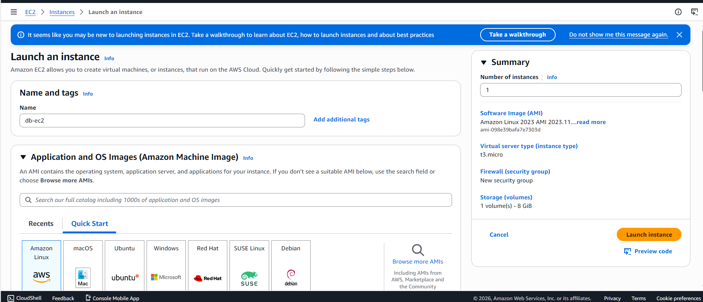
MariaDB server successfully installed and running on EC2
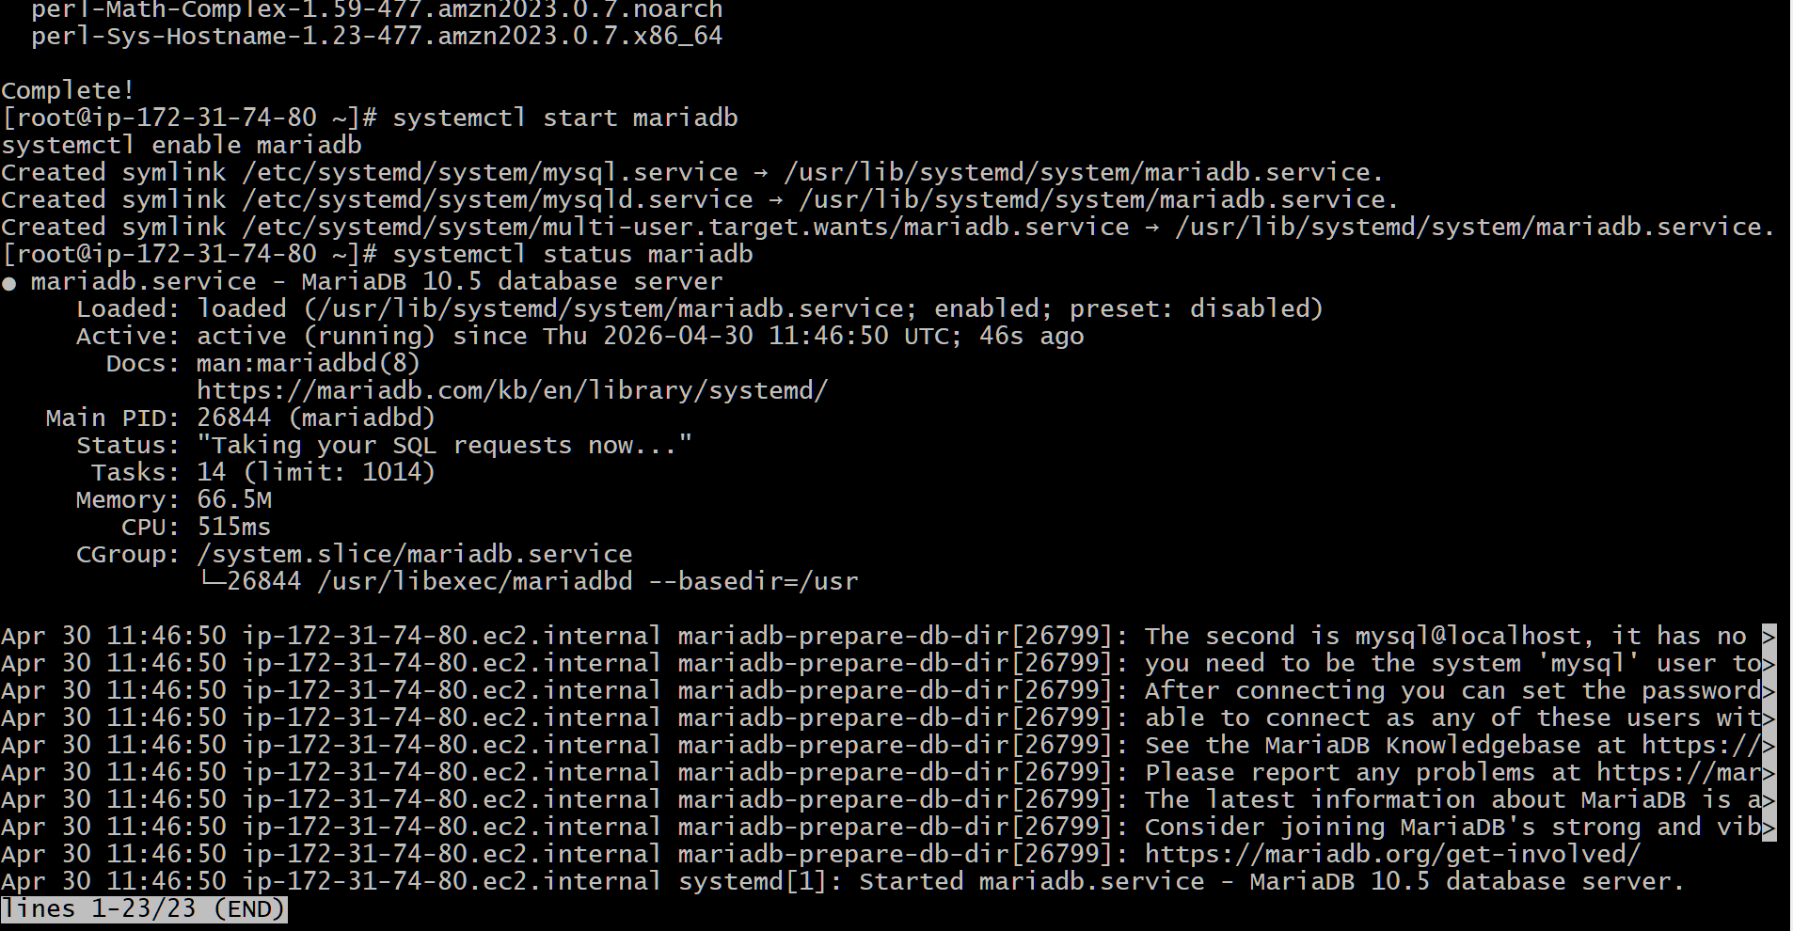
- Insert some dummy data.
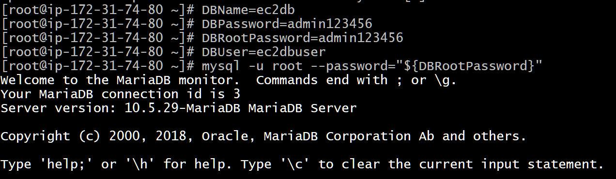
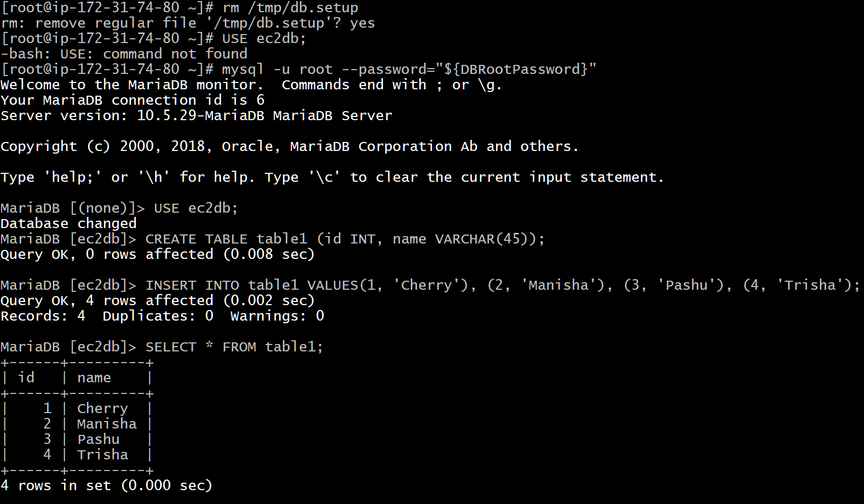
- Take the backup of dummy data on EC2.
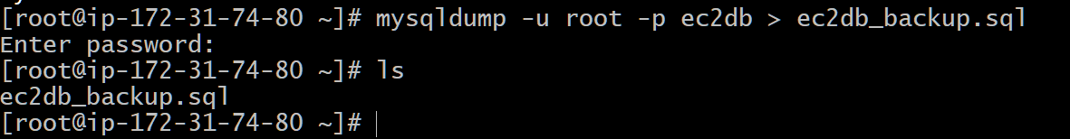
- Launch MariaDB RDS instance.
Open AWS → Go to RDS
Click Create Database
Choose MariaDB
Select Free Tier
Enter:
DB name
Username & Password
Choose instance: db.t3.micro
Select VPC
Enable Public Access (if needed)
Add security rule:
Port 3306 (MySQL)
Click Create Database
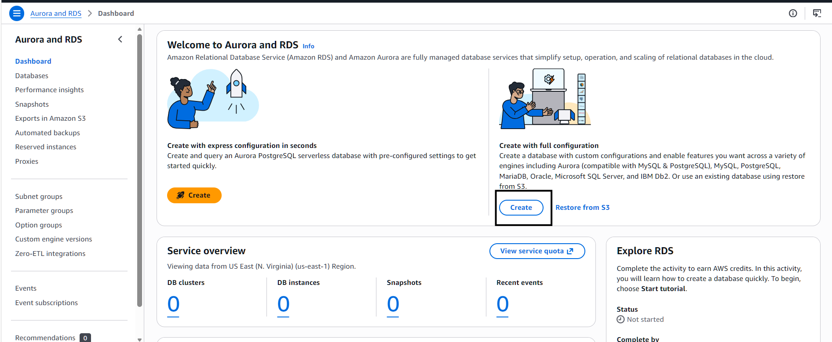
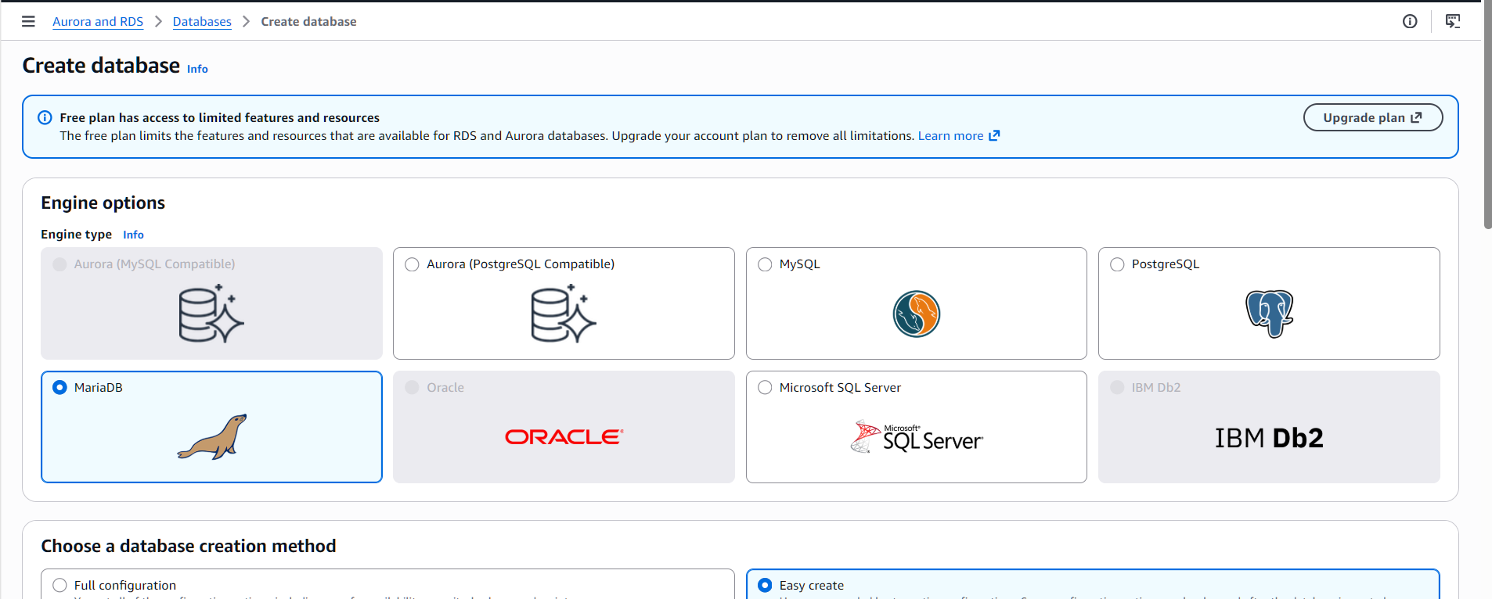
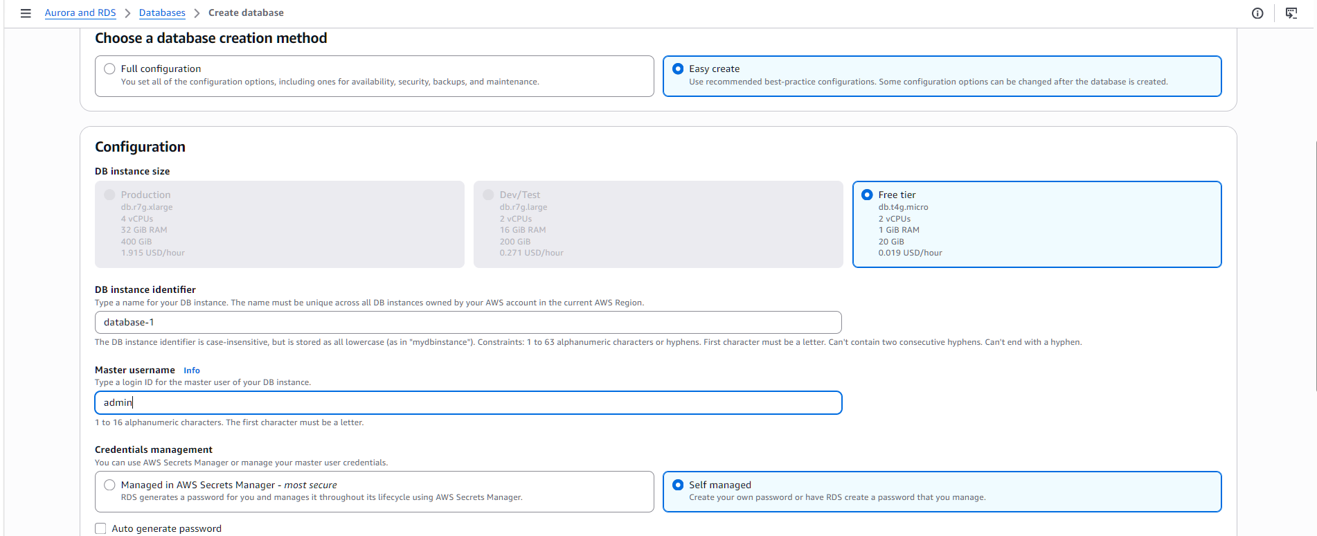
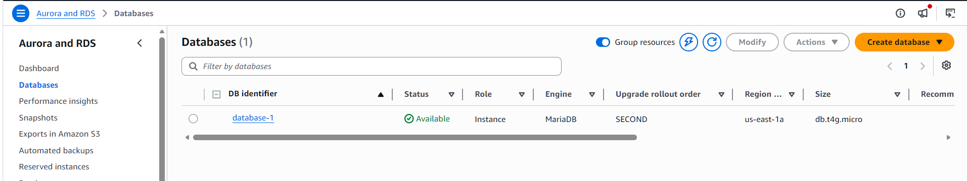
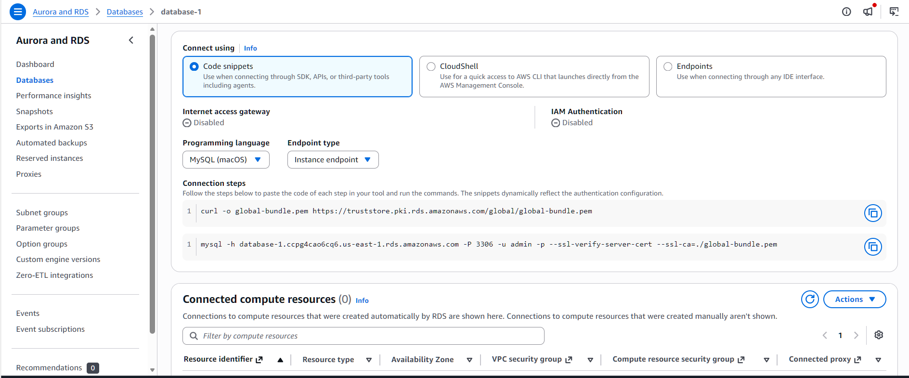
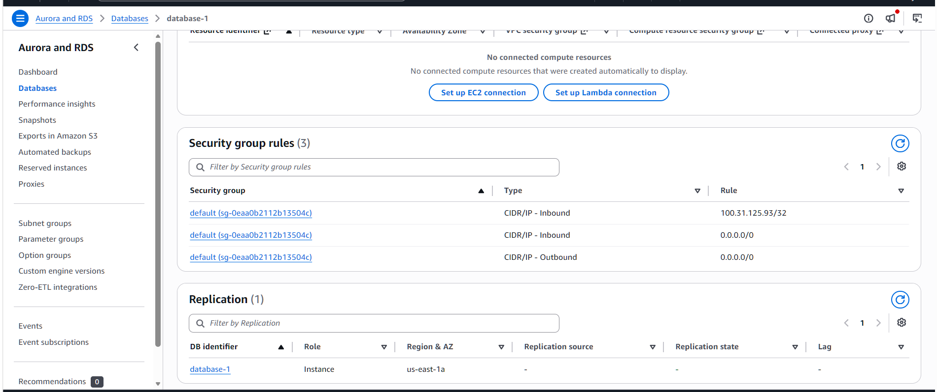
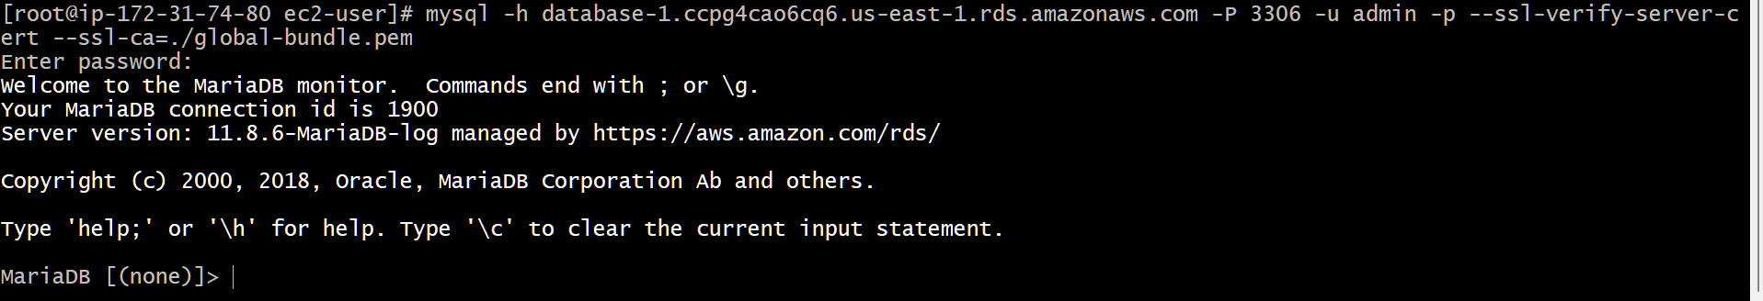

- Migrate database from EC2 to RDS.
Connected to the MariaDB RDS instance using SSL, created a new database, and verified successful execution.
Successfully migrated the database from EC2 to RDS using a backup file and verified the data by queryingthe table.
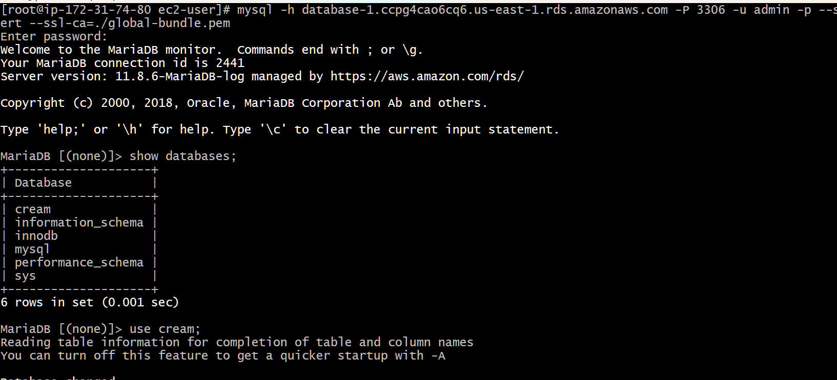
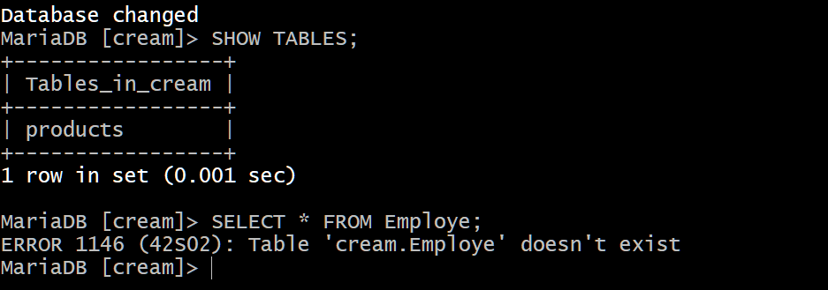
- Install MySQL DB on EC2.
Updated the EC2 system using sudo dnf update -y
Installed MySQL repository using official RPM package
Installed MySQL Community Server and required dependencies
Started MySQL service and enabled it
Retrieved temporary root password
Logged into MySQL successfully
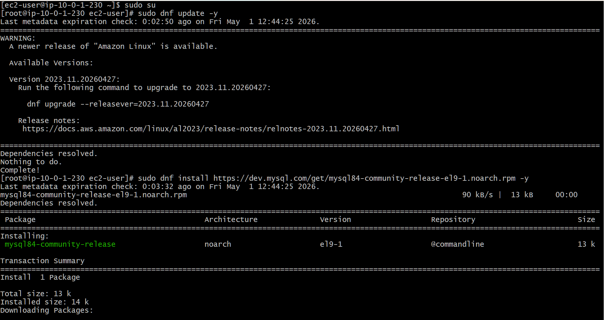
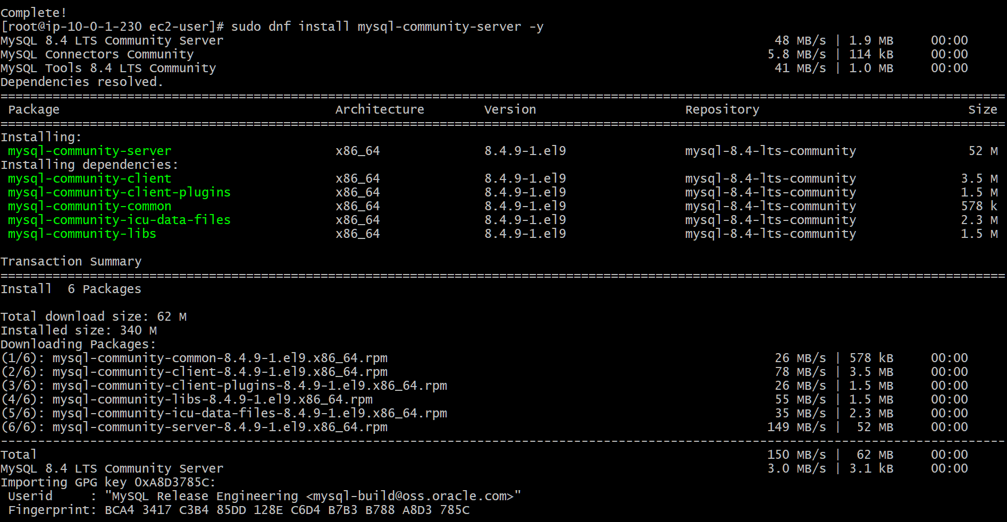
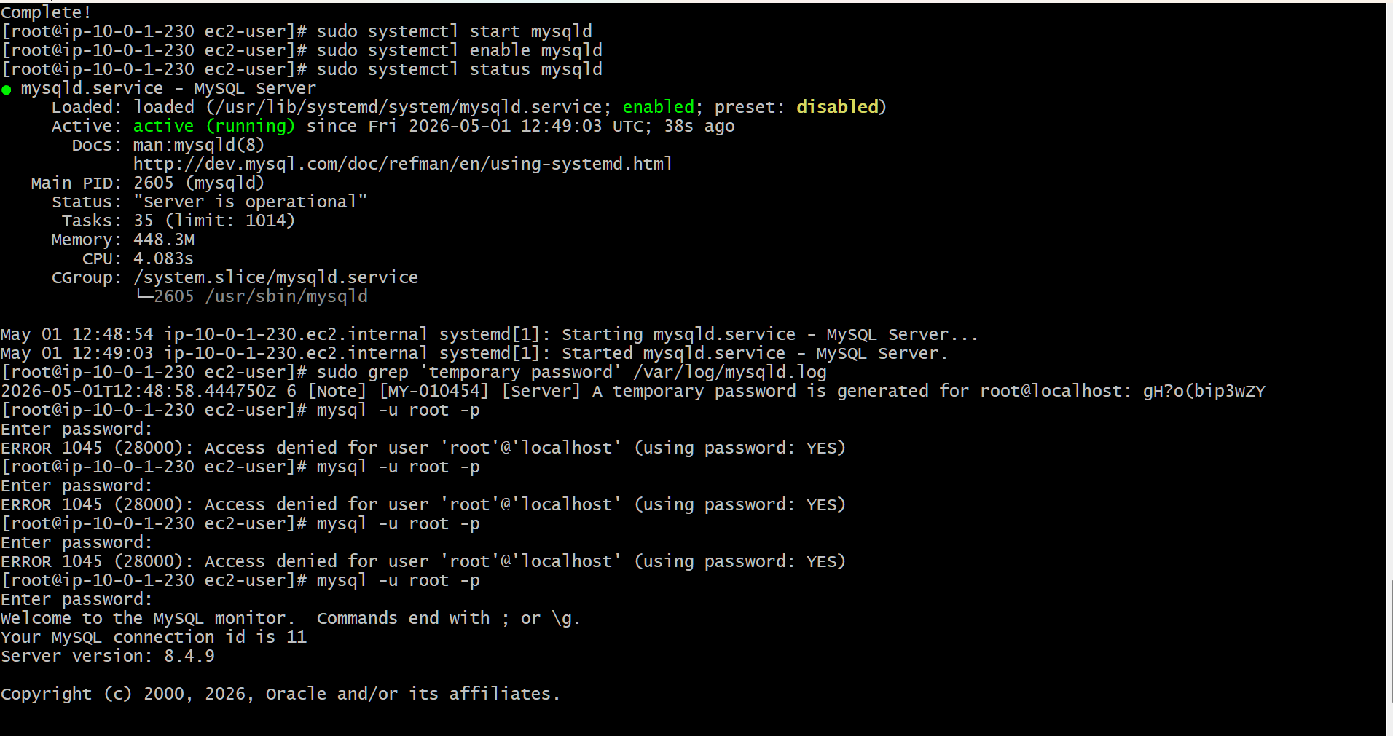
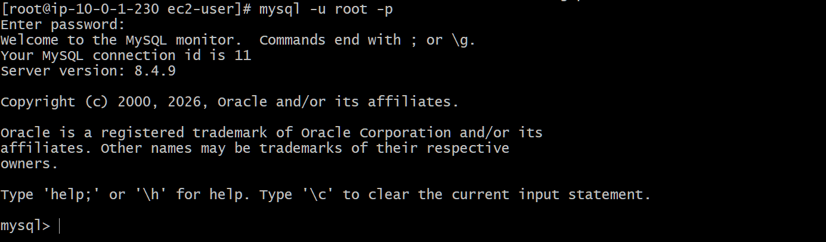
- Launch MySQL RDS image.
Successfully launched a MySQL RDS instance and verified its availability in AWS.
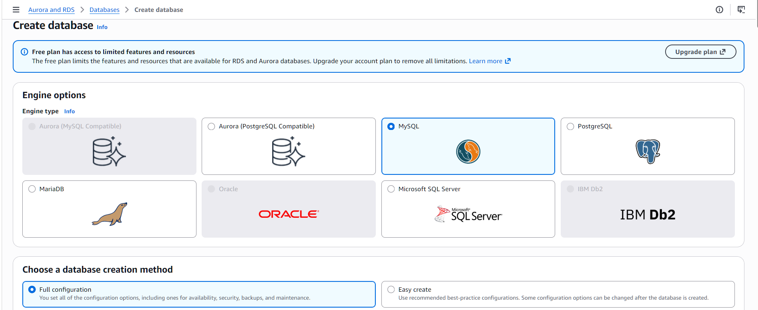
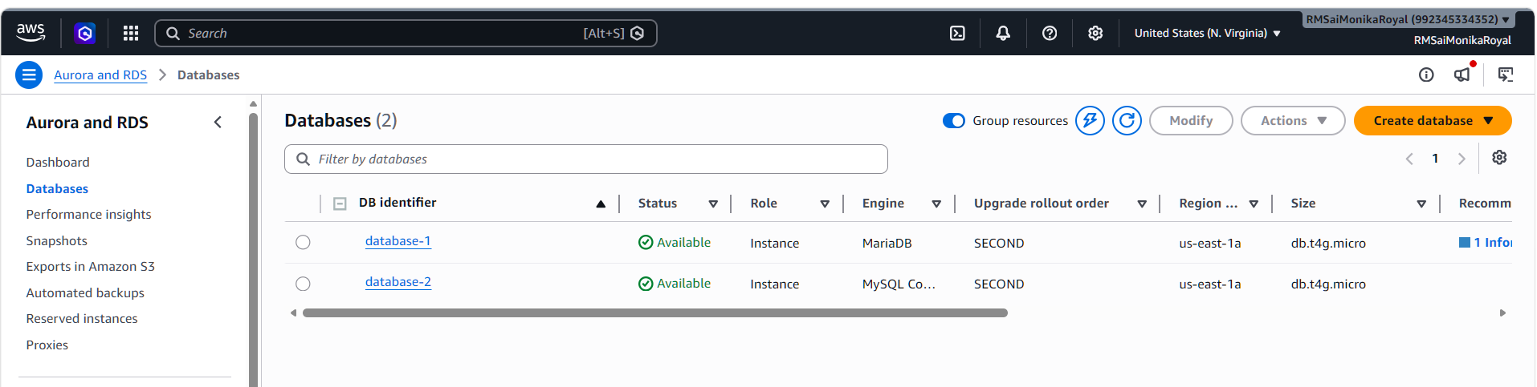
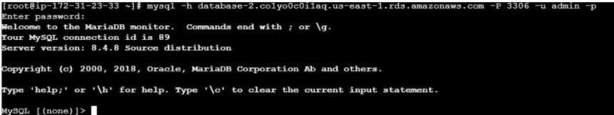

- Configure Multi-AZ.
Modified the RDS MySQL instance and enabled Multi-AZ deployment under availability settings.
• Applied changes immediately and verified that the instance status is available with Multi-AZ enabled.
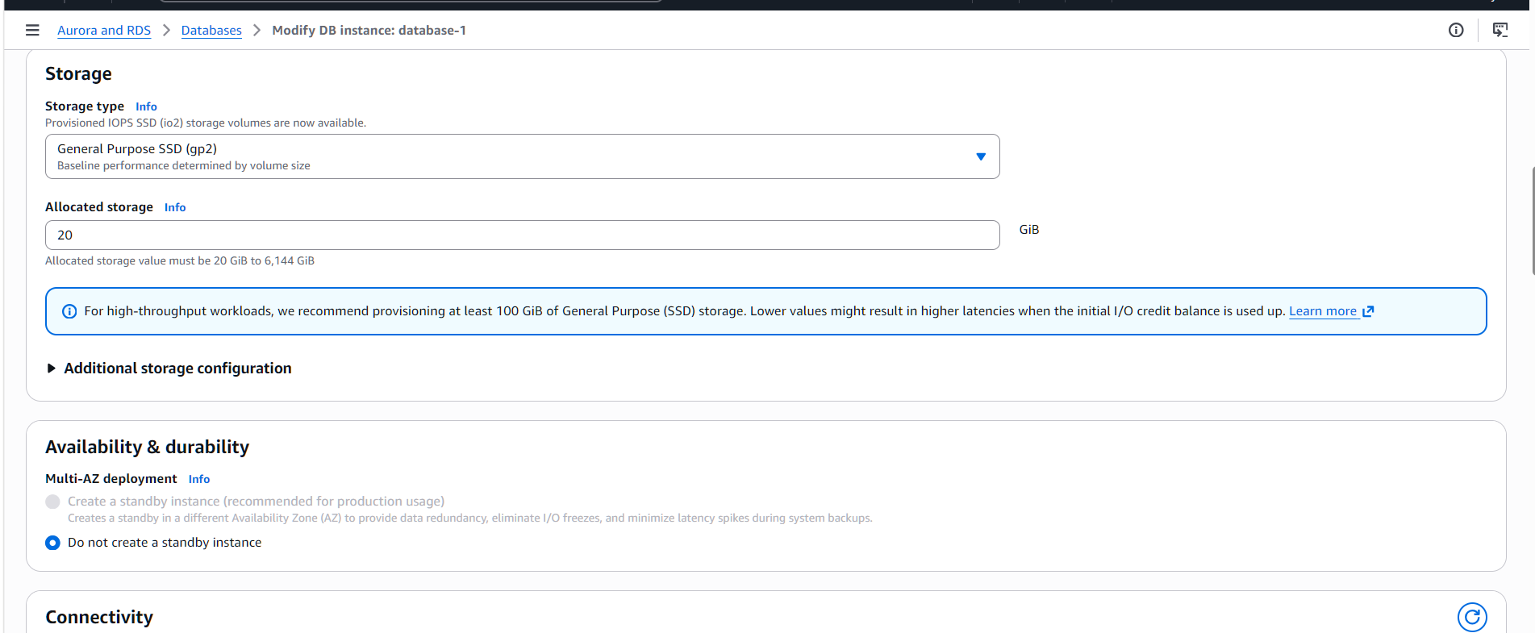
- Take backup of DB and restore the DB.
Took snapshot of the database-1 instance
Snapshot created successfully
Restored the snapshot
New RDS instance created from snapshot
Used it to simulate data recovery

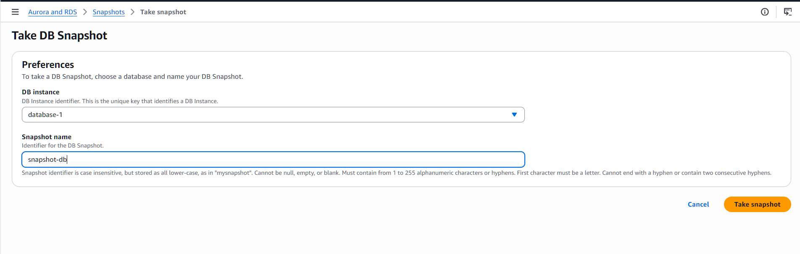
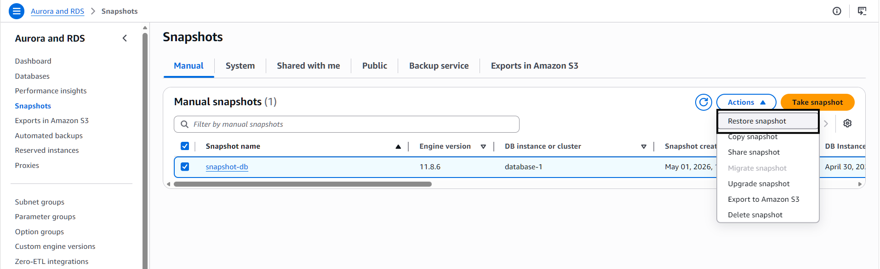
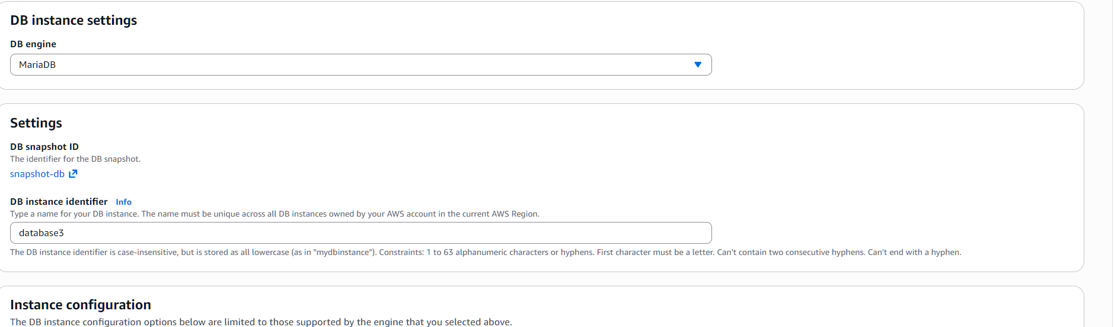
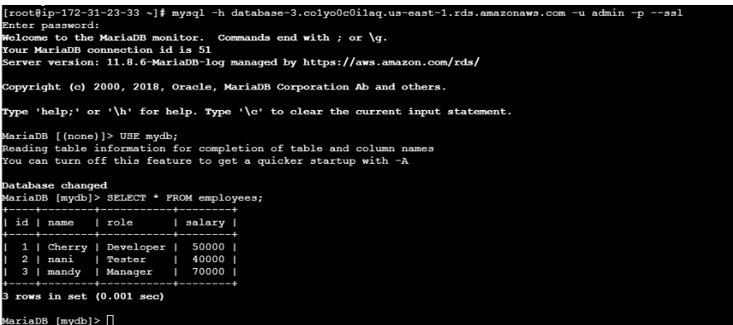
10.Create read replica.
Opened RDS database
Selected database-1
Clicked Actions → Create Read Replica
Replica created successfully

